
University Of Information Technology

Student’s Enrolling System
Software Requirement Specification

Project Code: QwQTeam2QwQ
Document Code: OoOTeam2OoO

<Ho Chi Minh city, 7/06/2021>

Record of change

*A - Added M - Modified D - Deleted
Effective Date | Changed Items | A*  M, D | Change Description | New Version
01/5/2021 | Initial | A | Add requirement list
08/05/2021 | Add Scope and Vision | A | Define Scope and Vision
22/05/2021 | Add Functional Requirement | A | Add use case, model diagram, business rules
05/06/2021 | Add Non-Functional Requirement | A | Add Non-Functional Document
19/06/2021 | Update use case | M | Update use case follow SDD
20/06/2021 | Update Non-Functional Requirement | M | Update Non-Functional Requirement follow use case

SIGNATURE PAGE

ORIGINATOR:

REVIEWERS:
Customer

APPROVAL: Nguyễn Thị Thanh Trúc XXX/06/2021
Instructor
TABLE OF CONTENTS
1 Introduction 6
1.1 Purpose 6
1.2 Project Scope and Product Features 6
1.3 Definitions, Acronyms, and Abbreviations 6
1.4 References 7
2 Overall Description 8
2.1 Product Perspective 8
2.2 User Classes and Characteristics 8
2.3 Operating Environment 9
2.4 Design and Implementation Constraints 9
2.5 Assumptions and Dependencies 9
3 FUNCTIONAL Requirements 10
3.1 The actors 10
3.2 The use cases 10
3.3 Use Cases Diagram 12
3.4 Login 13
3.5 Register phase 14
3.6 Scoring phase (Candidate Screen) 20
3.7 Scoring phase 22
4 NON-FUNCTIONAL Requirements 25
4.1 Usability 25
4.2 Performance 25
4.3 Supportability 25
4.4 Design Constraints 25
4.5 On-line User Documentation and Help System Requirements 26
4.6 Interfaces 26
4.7 Legal, Copyright, and Other Notice 34
5 Supporting Information 35

Introduction

Purpose
This SRS describes the functional and nonfunctional requirements for software release of the Student’s Enrolling System (SES). This document is intended to be used by the members of the project team who will implement and verify the correct functioning of the system. Document Conventions
No special typographical conventions are used in this SRS.

Project Scope and Product Features
The aim of this project is to develop a software system that would help Vietnam’s education have easier way to manage students/candidates through examinations or tests. SES provides school and teacher tools to control candidates list and separate exam process into three different phases with compatible function. These functions are:
- Login
- Log out
- Registering phase:
  - Uppdate Candidate’s data
  - Search Candidate by name
  - Set exam date (admin)
  - Finish Registering phase (admin)
- Scoring phase:
  - View Candidates List
  - Set test score
  - Set Benchmark
  - Finish Scoring phase (admin)
- Finish phase:
  - View statistic phase

Definitions, Acronyms, and Abbreviations
SES divide process of an exam into three phases, those are:
- Registering phase: A period of time that candidate’s can submit their information.
- Scoring phase: After finish Registering phase, SES will go to Scoring phase. At this phase, user set candidate’s score into SES and export inform letter
- Finish phase: After finish scoring phase, SES will go to Scoring phase. At this phase, user can export result letter

References
- SES Business rules: Defines or constrains some aspect of business in SES
- SES Software Detail Design: Deals with the implementation part of what is seen as a system and its sub-systems
- SES Use Case: A description of how a person who actually uses that process or system will accomplish a goal

Overall Description

Product Perspective
The Student’s Enrolling System is a new software system that replaces the current procedure in examinations in Vietnam. The context diagram in Figure 1 illustrates the external entities and system interfaces for release 1.0. The system is expected to evolve over several releases, ultimately connecting to the Internet ordering services for several local school and to login and update database.
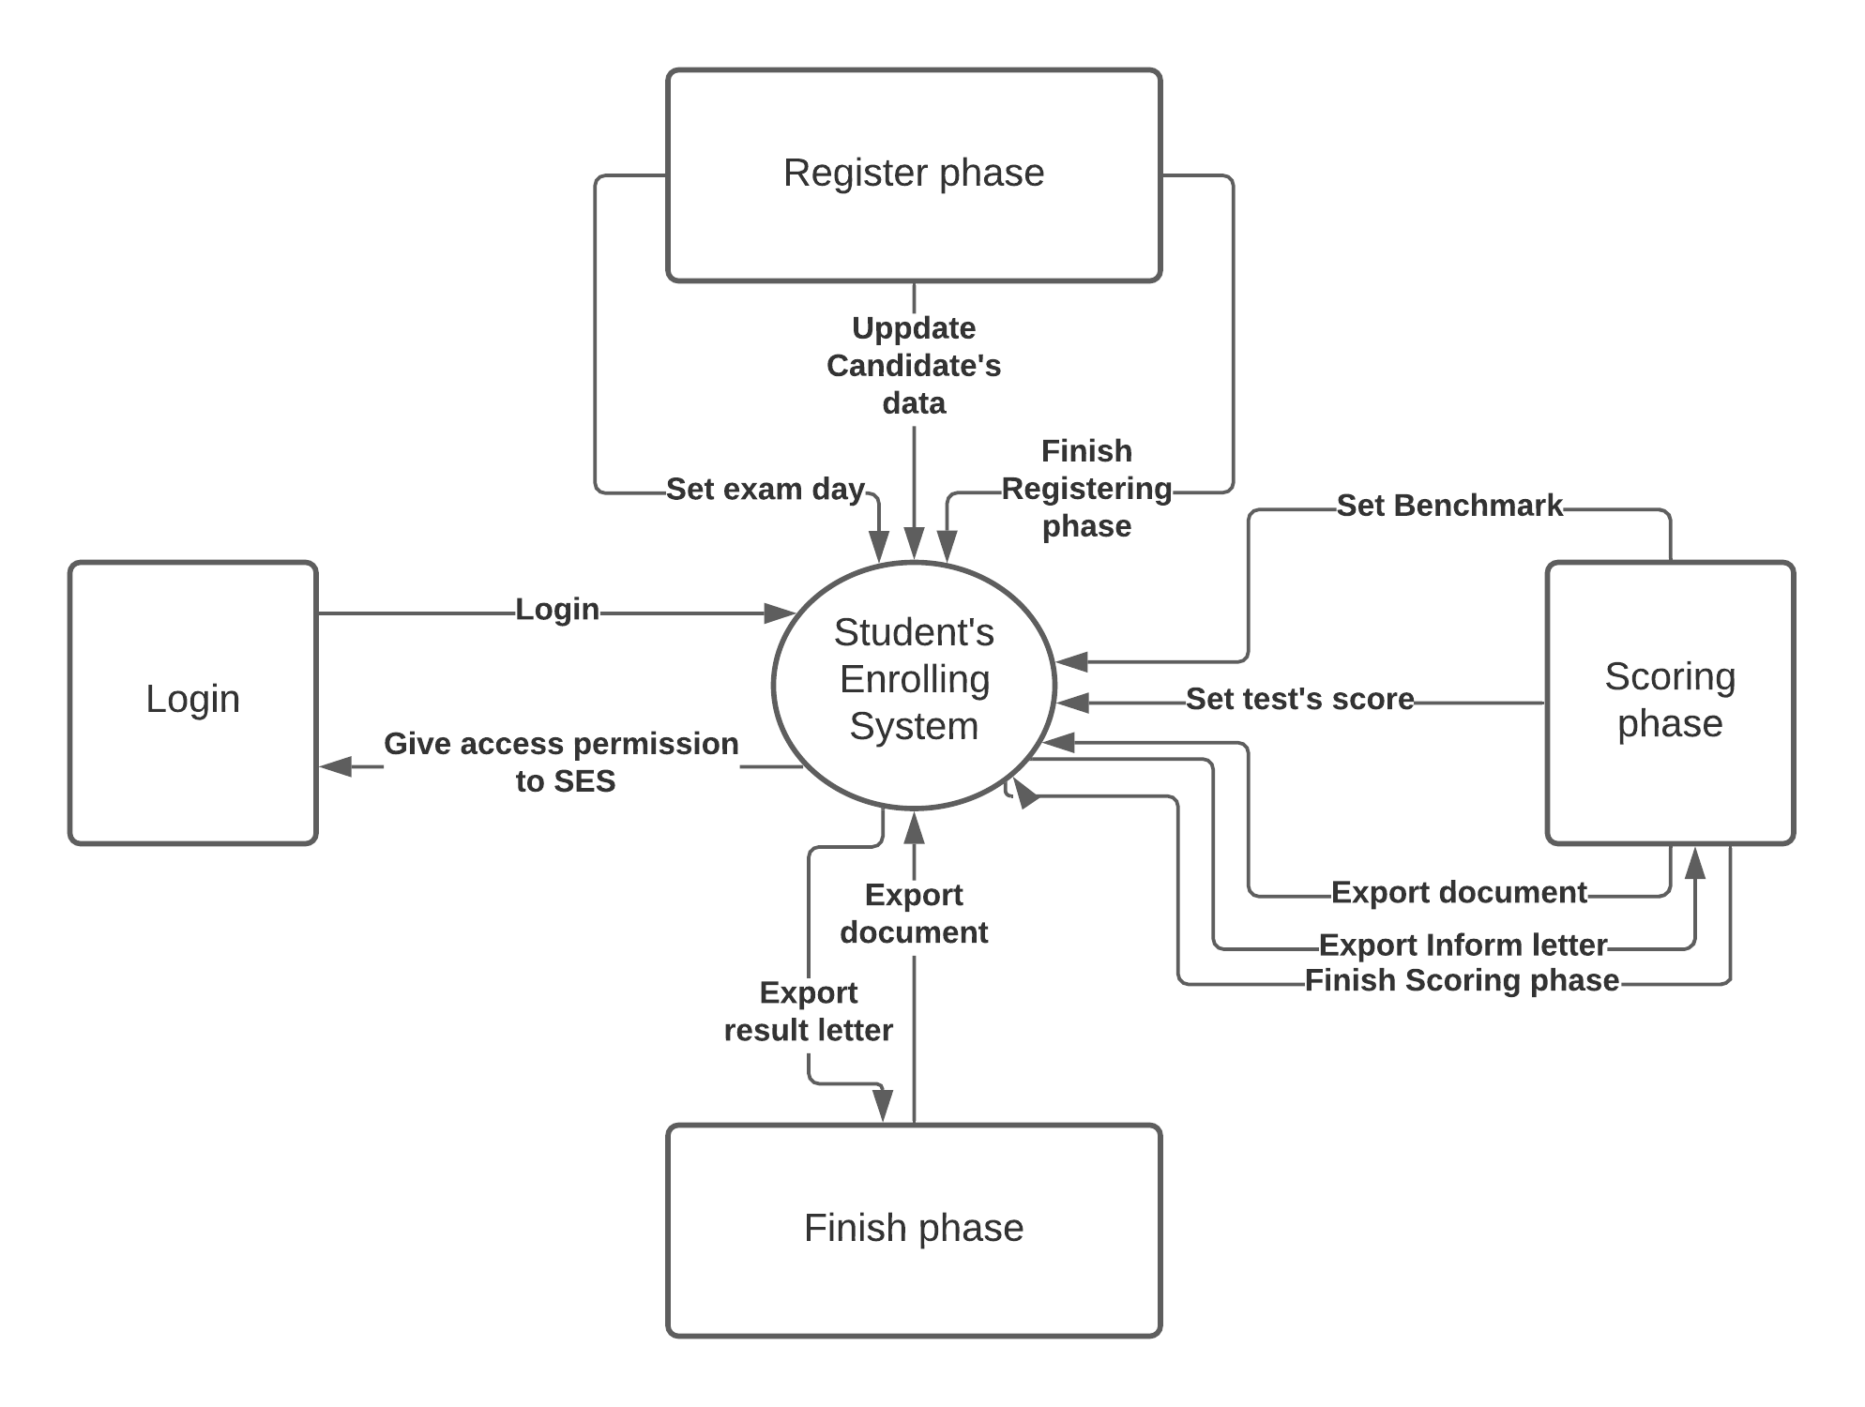
Figure 1. Context diagram for release 1.0 of the Student’s Enrolling System.

User Classes and Characteristics
Teacher | The Process Impact SES employs all teacher representative from all school in Vietnam, who will receive data from the candidates, update database, score candidate and print letter to candidate base on database.
Admin | The Admin is the one who establishes exam day and set phase on SES. Admin can access all function in SES

Operating Environment
OE-1: The SES shall operate on a server running the current corporate-approved versions of Windows.
OE-2: The SES shall permit user access from the corporate Intranet, from a VPN Internet connection.

Design and Implementation Constraints
CO-1: The system’s design, and maintenance documentation shall conform to the SES Detailed Design.
CO-2: The system shall use the current corporate standard Azure database engine.

Assumptions and Dependencies
AS-1: The examination is open for mid-term exam, final exam and every exam that have specific procedure.
DE-1: The operation of the SES depends on changes being made in the number of exam room.
DE-2: The operation of the SES depends on changes being made in the output constraint to result.

FUNCTIONAL Requirements

The actors
# | Main functions | Teacher | Admin
1 | Update database | x | x
2 | Set exam date |  | x
3 | Export document | x | x
4 | Set Candidate’s score | x | x
5 | Set Registering phase end |  | x
6 | Set Scoring phase end |  | x
7 | Set Benchmark |  | x
8 | View Statistic | x | x
9 | Login | x | x

The use cases
System Functions | Main Use Cases |  | Use Case #
Login
Login |  | Login | UC_1
Registering phase
Update database | Add candidate |  | UC_2.1
Update database | Edit candidate |  | UC_2.2
Update database | Delete candidate |  | UC_2.3
Set exam date | Set exam date |  | UC_3
Set Registering phase end | Finish registering |  | UC_4
Scoring phase
Set Candidate’s score | Set Score |  | UC_5
Export document | Export inform letter |  | UC_6
Set Benchmark | Set Benchmark |  | UC_7
Set Scoring phase end | Confirm Score |  | UC_8
Finish phase
Export document | Export result letter |  | UC_6
View Statistic | View Statistic |  | UC_9

Use Cases Diagram
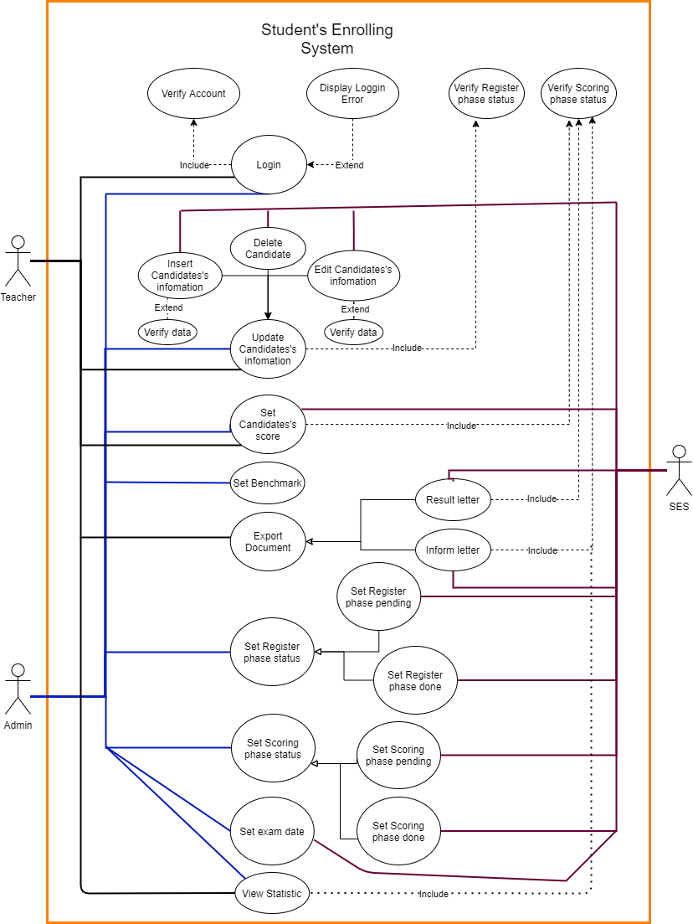

Login

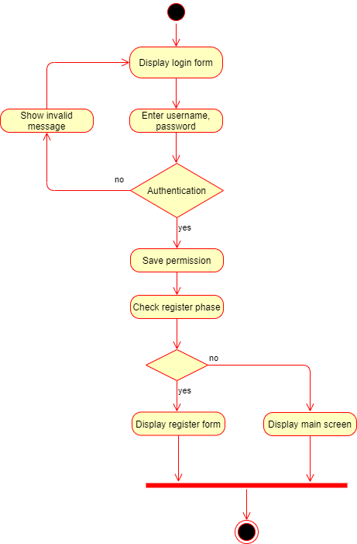

Login.
ID and Name: | UC-1 Login into SES
Created By: | Nguyễn Trung Hiếu | Date Created: | 19/04/2021
Primary Actor: | Teacher | Secondary Actors: | Admin
Description: | A Patron accesses the SES from the office computer or from PC, login into the SES by the accounts in manual provided to insert cadidate’s infomation.
Trigger: | A patron login into SES
Preconditions: | PRE-1. Patron open SES by click SES’s Shortcut
Postconditions: | POST-1. Patron loggin into SES
Normal Flow: | 1.0 Login into SES  - Patron open SES by click SES’s Shortcut.  - SES display Login screen (SDD ****).  - Patron use account (in manual) to access SES.  - Patron Login into SES.
Alternative Flows: | None
Exceptions: | 1.0.E1 Account not valid  1. SES give patron message “Authention Failed”  2. Patron click “OK”  3. Return 1.0.2  1.0.E2 Patron click “X” button in top-right login Screen  1. Exit SES
Priority: | High
Business Rules: | BR-1, BR-2

Register phase

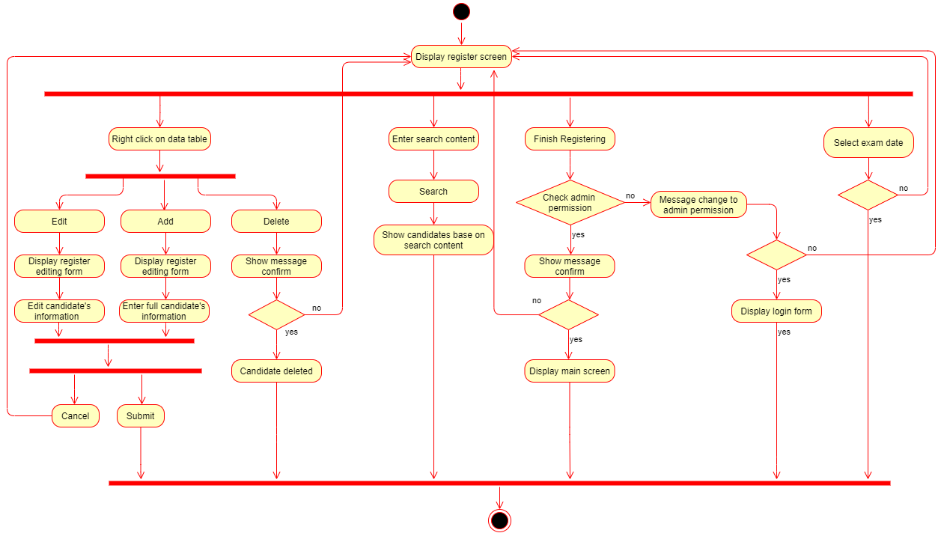

Add Candidate

ID and Name: | UC-2.1 Add Candidate’s Infomatioin
Created By: | Nguyễn Trung Hiếu/Phùng Thanh Tú | Date Created: | 20/06/2021
Primary Actor: | Teacher | Secondary Actors: | Admin
Description: | A Patron accesses the SES from the office computer or from PC, login into the SES by the accounts in manual provided to insert cadidate’s infomation.
Trigger: | A patron login into SES
Preconditions: | PRE-1. Patron is logged into SES.  PRE-2. Input type must be correct.
Postconditions: | POST-1. SES database is updated to reflect candidates’s information changed.
Normal Flow: | 2.1 Add Candidate’s Infomation  - Patron login to SES.  - Patron press right click.  - Patron click Add.  - Patron fill information of a candidate in “Register Edit” screen.  - Patron click “Submit” button.  - SES display message “Saved”.  - Candidate’s information save to database.  - “Registed Edit” Screen disappear.
Alternative Flows: | None
Exceptions: | 2.1.E1 Input type is not correct  1. SES give patron message “Incorrect” + type (incorected type)  2. Patron change data to match input type, or click “CANCEL” button to cancel inserting  2.1.E2 Textbox is blank  1. COS informs Patron that no delivery times are available for the meal date.  2. If Patron cancels the meal ordering process, then COS terminates use case.  2.1.E3 Patron click “CANCEL” button  1. Return 1.1
Priority: | High
Business Rules: | BR-3, BR-4

Delete Candidate

ID and Name: | UC-2.2 Delete Candidate’s Infomatioin
Created By: | Nguyễn Trung Hiếu/Phùng Thanh Tú | Date Created: | 20/06/2021
Primary Actor: | Patron | Secondary Actors: | SES
Description: | A Patron accesses the SES from the office computer or from PC, login into the SES by the accounts in manual provided to delete cadidate’s infomation.
Trigger: | A Patron indicates that he wants to order a meal
Preconditions: | PRE-2. Patron is logged into SES.
Postconditions: | POST-2. SES database is updated to reflect candidates’s information changed.
Normal Flow: | 2.2.0 Insert Candidate’s Infomation  1. Patron choose a candidate to remove  2. Patron click right click  2. Patron click “Delete”.  3. Candidate’s information remove from database.
Alternative Flows: | None
Priority: | High
Business Rules: | BR-3, BR-4

Edit Candidate

ID and Name: | UC-2.3 Edit Candidate’s Infomatioin
Created By: | Nguyễn Trung Hiếu/Phùng Thanh Tú | Date Created: | 21/06/2021
Primary Actor: | Patron | Secondary Actors: | SES
Description: | A Patron accesses the SES from the office computer or from PC, login into the SES by the accounts in manual provided to edit cadidate’s infomation.
Trigger: | A Patron indicates that he wants to order a meal
Preconditions: | PRE-3. Patron is logged into SES.
Postconditions: | POST-3. SES database is updated to reflect candidates’s information changed.
Normal Flow: | 2.3.1 Edit Candidate’s Infomation  - Patron choose candidate’s infomation to edit.  - Patron click right click  - Patron edit candidate’s information in “Register Edit” screen.  - Patron click “EDIT”.  - SES display message “Saved”.  - Candidate’s information save to database.  - “Registed Edit” Screen disappear.
Alternative Flows: | 2.3.0.E1 Input type is not correct  1. SES give patron message “Incorrect” + type (incorected type)  2. Patron change data to match input type, or click “CANCEL” button to cancel inserting  2.3.1.E2 Textbox is blank  1. COS informs Patron that no delivery times are available for the meal date.  2. If Patron cancels the meal ordering process, then COS terminates use case.  2.3.2.E3 Patron click “CANCEL” button  - 1. Return 1.3.1
Exceptions: | None
Priority: | High
Business Rules: | BR-3, BR-4

Set Registering phase end
ID and Name: | UC-3 Set Registering phase end
Created By: | Nguyễn Trung Hiếu/Phùng Thanh Tú | Date Created: | 21/6/21
Primary Actor: | Admin | Secondary Actors: | SES
Description: | Admin want to set status of Register phase
Trigger: | Admin click “Finish Registering” button or “Reset Register phase” button
Preconditions: | PRE-3. Admin is logged into COS.  PRE-3.1. Register phase is not finished.  PRE-3.2. Register phase finished.
Postconditions: | POST-6. Register phase status changed.
Normal Flow: | 3.0 Set Register phase end  - Admin loggin into SES.  - SES display “REGISTERING INFORMATION” screen  - Admin click “FINISH REGISTERING” button  - SES display message to confirm action on the screen.  - Admin click Yes and finish register phase.  - Register phase status save into database.  3.1 Set Register phase reset  - Admin loggin into SES.  - SES display “Main” screen  - Admin click “RESET REGISTER PHASE” button  - SES display message to confirm action on the screen.  - Admin click Yes and finish register phase.  - Register phase status save into database.
Alternative Flows: | None
Exceptions: | None
Priority: | High
Business Rules: | BR-2, BR-3.

Set exam day

ID and Name: | UC-4 Set exam day
Created By: | Nguyễn Trung Hiếu/Phùng Thanh Tú | Date Created: | 20/06/2021
Primary Actor: | Admin | Secondary Actors: | SES
Description: | Admin want to set exam day
Trigger: | Admin click exam day box
Preconditions: | PRE-4. Admin is logged into COS.  PRE-4.1. Register phase is not finished
Postconditions: | POST-4. Exam day save to database
Normal Flow: | 4.0 Set Exam Day  - Admin login into SES.  - Admin click “Set Ngày Thi” box  - SES display day picker box  - Admin click on a day.  - Admin click “FINISH REGISTER” button  - Exam day save to database
Priority: | High
Business Rules: | BR-2, BR-3
Other Information:

Scoring phase (Candidate Screen)

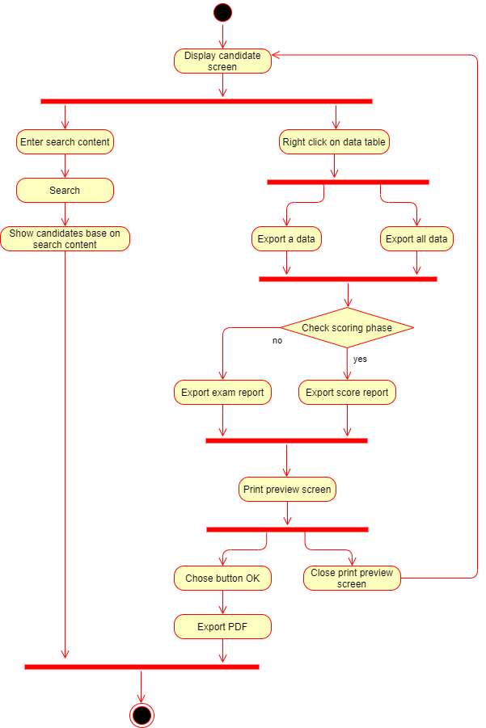

ID and Name: | UC-6 Export document from database
Created By: | Nguyễn Thanh Nga | Date Created: | 11/06/2021
Primary Actor: | Patron | Secondary Actors: | SES
Description: | Patron want to print document from candidates list
Trigger: | When Register phase is done or Scoring phase is done
Preconditions: | PRE-6. Patron is logged into COS.  PRE-6.1. Register phase is done.  PRE-6.2. Scoring phase is done
Postconditions: | POST-6. Patron have document they need.
Normal Flow: | 6.1 Export Candidate’s letter  - Patron click “CANDIDATES” button  - SES display “CANDIDATE” screen.  - Patron choose a candidate to export letter.  - Patron click right click.  - Patron choose “export data” or “export all”.
Alternative Flows: | 6.1.1 Scoring phase is not ended  1. Patron click “export data” or “export all”to print letter to candidate.  2. SES display preview inform letter.  3. Patron click print to print inform letter  6.1.2 Scoring phase is ended  1. Patron click “export data” or “export all”to print letter to candidate.  2. SES display preview result letter.  3. Patron click print to print result letter
Exceptions: | None
Priority: | High
Business Rules: | BR-4, BR-5, BR-6
Other Information: | Expect high frequency of executing this use case within first 2 weeks after system is released.

Scoring phase
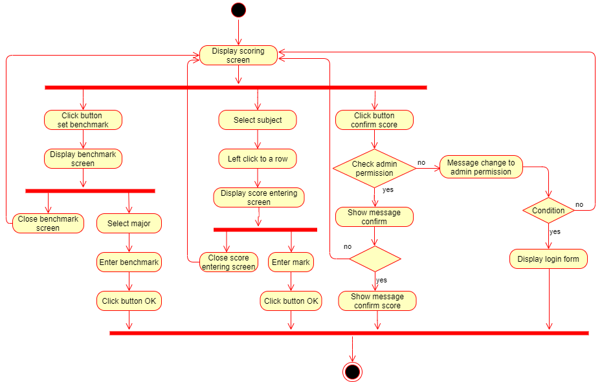

Set Candidate’s Score
ID and Name: | UC-5 Set Candidate’s Score
Created By: | Nguyễn Trung Hiếu/Phùng Thanh Tú | Date Created: | 20/06/2021
Primary Actor: | Patron | Secondary Actors: | SES
Description: | A Patron accesses the SES to insert cadidate’s score after Register phase end.
Trigger: | Register phase is end.
Preconditions: | PRE-5. Patron is logged into COS.  PRE-5. Register phase have been done.
Postconditions: | POST-5. SES database candidates’s result is updated to reflect candidates’s result changed.
Normal Flow: | 5.0 Set Candidate’s Score  - Patron click “Scoring” button  - Patron click double left click to the test that patron want to set score  - SES display “Score Edit” Screen  - Patron set candidate’s score  - Patron click “OK” button  - Candidate’s results save to SES database
Alternative Flows: | None
Exceptions: | None
Priority: | High
Business Rules: | BR-6
Other Information: | - Admin decides whether subject scoring done

ID and Name: | UC-7 Set benchmark
Created By: | Phùng Thanh Tú | Date Created: | 21/06/2021
Primary Actor: | Patron | Secondary Actors: | SES
Description: | Patron want to set benchmark of major
Trigger: | When Register phase is done or Scoring phase is done
Preconditions: | PRE-7. Admin is logged into COS.  PRE-7.1. Register phase is done.
Postconditions: | POST-7. Benchmark save to database.
Normal Flow: | 7.1 Set benchmark  - Patron click “SCORE EDIT” button  - SES display “SCORING” screen.  - Patron click “SET BENCHMARK” button.  - Patron choose major.  - Patron set benchmark.  - SES save major benchmark
Alternative Flows: | 7.1.1 Patron click “X” button  1. Return 7.1.7
Exceptions: | None
Priority: | High
Business Rules: | BR-4, BR-5, BR-6
Other Information: | Expect high frequency of executing this use case within first 2 weeks after system is released.

ID and Name: | UC-8 Set Scoring phase end
Created By: | Nguyễn Trung Hiếu/Phùng Thanh Tú | Date Created: | 22/06/21
Primary Actor: | Admin | Secondary Actors: | SES
Description: | Admin want to set status of Scoring phase
Trigger: | Admin click all “Confirm” button in all subject
Preconditions: | PRE-8. Admin is logged into COS.  PRE-8.1. Register phase finished.
Postconditions: | POST-8. Scoring phase status changed.  POST-8.1. All subjects are confirmed
Normal Flow: | 8.0 Set Scoring phase end  - Admin loggin into SES.  - Admin click “SCORING” button  - SES display “SCORING” screen  - Admin click “CONFIRM SCORE” button.  - Scoring phase in SES is end
Priority: | High
Business Rules: | BR-2, BR-3. BR-5, BR-6
Other Information: | Expect high frequency of executing this use case within first 2 weeks after system is released.

View Statistic
ID and Name: | UC-9 View Statistic
Created By: | Phùng Thanh Tú | Date Created: | 22/06/21
Primary Actor: | User | Secondary Actors: | Admin
Description: | Patron want to see statistic of the examination
Trigger: | Admin click “STATISTIC” button
Preconditions: | PRE-9. Admin is logged into COS.  PRE-9.1. Register phase is finished
Postconditions: | POST-9. Exam day save to database
Normal Flow: | 9.0 View Statistic  - Patron login into SES.  - Admin click “STATISTIC” box  - SES display “Statistic” screen
Priority: | High
Business Rules: | BR-2, BR-3

NON-FUNCTIONAL Requirements

Usability
US-1: A stack-navigation menu to help users move freely between sections.
US-2: All of the buttons are labeled with the main functionality on them and color to help users not being confused about their functions.
US-3: In the process of input data, if users violate the input regulation, the program will pop up to warn the users after they click on the “Confirm” button. (They cannot continue the process if the error is not solved)

Performance
PR-1: After end Registering phase, data in Register form modify to Candidate list must be within 5s.
PR-2: The program must react to the users within 1s.
PR-3: All the screens (included input and output screens) must be set to ready for users within 3 seconds with the conditions:
PR-3.1: There is no error in terms of input regulation.
PR-3.2: The minimum requirement of the user’s system to run the program: Intel core I3, 1Gb RAM, 1Gb hard disk.

Supportability
[This section indicates any requirements that will enhance the supportability or maintainability of the system being built, including coding standards, naming conventions, class libraries, maintenance access, and maintenance utilities.]

<Supportability Requirement One>
[The requirement description goes here.]

Design Constraints
DS-C1: Build tool is WPF, use SQL Server as database
DS-C2: All screen separate into three phase. After a phase has been finished, all function in previous phase can not be use.
DS-C3: Admin has permission to access all function User have. User cannot access Admin function
DS-C4: Only way to reset system is use special tool.

On-line User Documentation and Help System Requirements
SES provide only two kind of account (see in manual) with limited amount. Account is unchangeable so that customer must secure these account.

Interfaces
UI-1: Screen Login
UI-2: Screen in Registering phase: Register Screen
UI-3: Screen in Scoring phase and Finish phase: Main Screen, Candidate Screen, Score Screen, Statistic Screen

Hardware Interfaces

Login
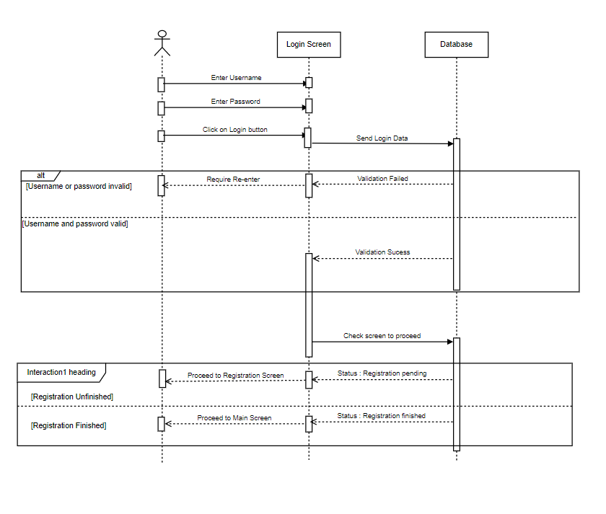
4.6.1.1 Login Sequence diagram

Register a Candidate
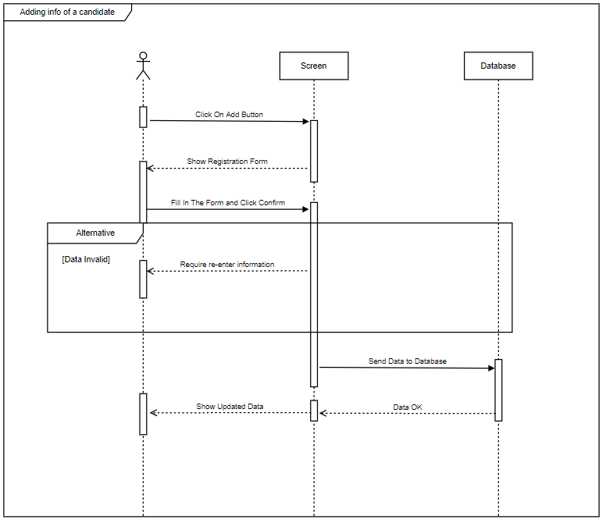
4.6.1.2 Register Sequence diagram

Edit an existing Candidate in Registration Screen
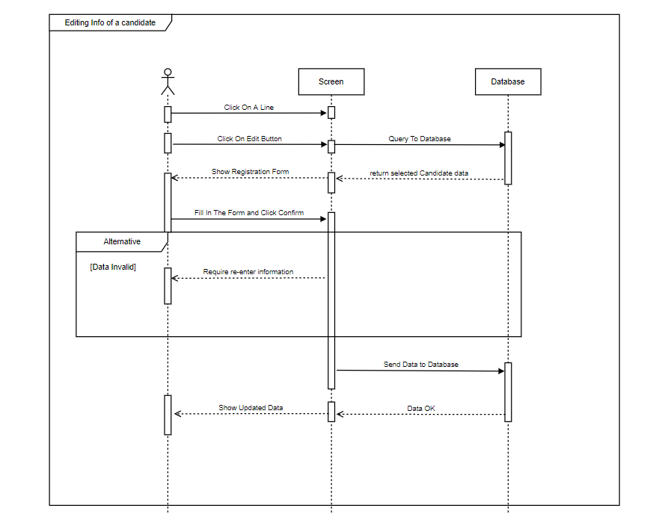
4.6.1.3 Edit Sequence diagram

Finish Candidate Registration
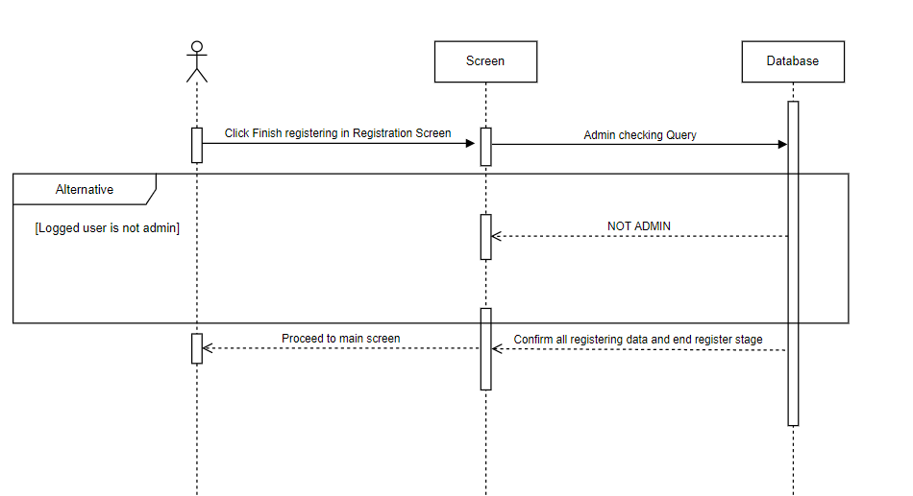
4.6.1.4 Finish Register phase Sequence diagram

Edit Scores
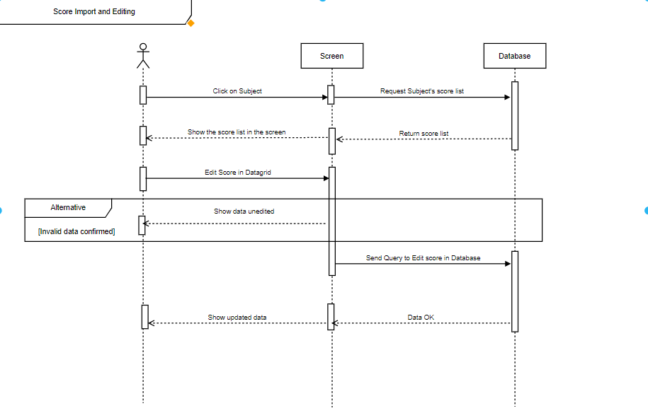
4.6.1.5 Edit Scores Sequence diagram

Export Candidates Data
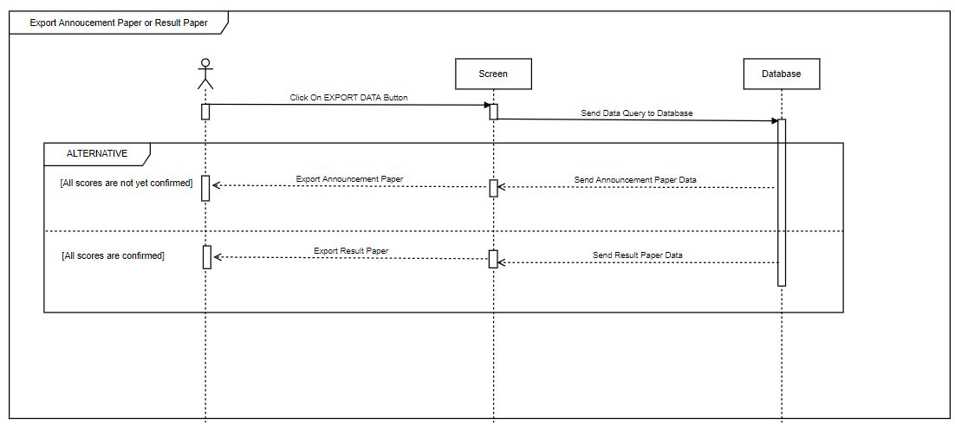
4.6.1.6 Export Sequence diagram

Show Statistics
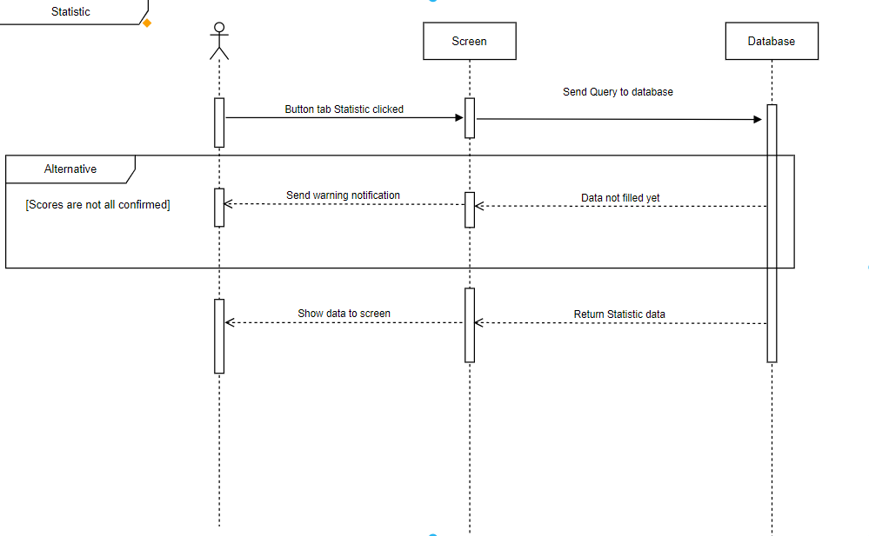
4.6.1.7 Show Statistic Sequence diagram

Software Interfaces
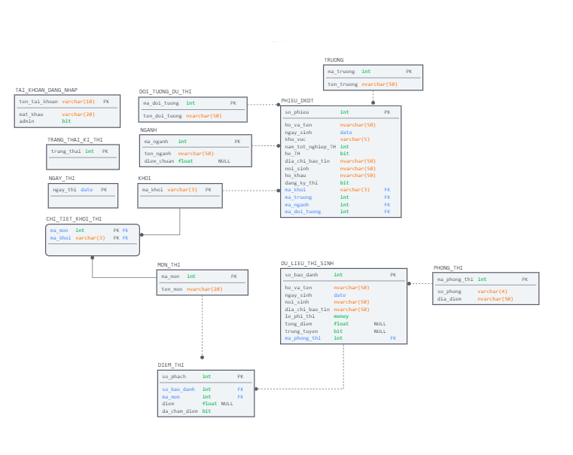
4.6.2 SES ERD

Legal, Copyright, and Other Notice
This project is an open source system, everyone can contribute to SES in any ways they want

Supporting Information
- User and Admin:
- System instruction for use, instruction of customer right.
- Analysist:
- Evaluating System Description.
- Evaluating Use case diagram.
- Analyzing business rules.
- Developer:
- Follow diagrams, model to understand about project.
- Optimize constraints of model and diagram.
- Tester:
- Have information for unit test and system test.

